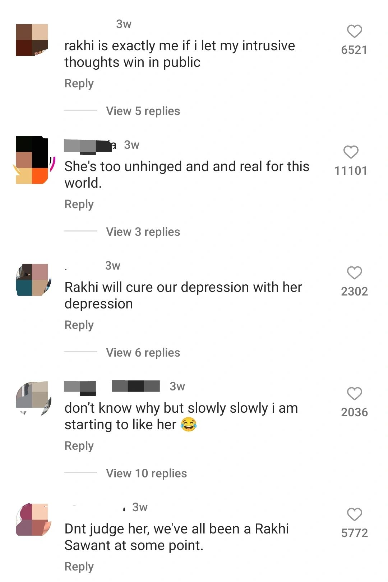

You are cringe.

But what happens when you really accept it? and own it?

Action. Creation. Expression.

"Kya mai wahi" was one of the first music videos I ever created, in 2020.

I had a humble Samsung worth 10k.

Few thoughts in my head that I wrote down on a paper.

A certain feeling that I wanted to express through it.

That was it.

Wrote the lyrics, composed a tune, went out on my activa at 4 a.m trying to get some random shots, ended up recording myself playing with cute doggo siblings, recorded the song, came to terms with the fact that everyone hates their recorded voice- did some music and video edition, voila.

I had created a lofi indie bedroom hiphop music video.

Was I brave enough to post it?

nope.

"kya chomu gaana hai"

"This isn't hip hop"

"Cringe stuff. "

Were all the comments I expected, and in that expectation, these were the comments I was making about myself.

These are the self limiting thoughts that everyone keeps talking about.

Why did I make the whole thing in the first place?

I was just feeling a certain way, and wanted to extend it.

Cringe or not, It didn't matter.

It was just another snapshot of the human experience and expression.

The rise of influencers like Puneet superstar, and Dhinkchak Pooja some time before only points at one thing-

A segment of the media consumer today- the Gen Z, has a meta awareness of the intent behind the content.

A Post-modern understanding of content and mediums is present among the youth- they not only look at content, but actively create their own meanings out of it, which in itself becomes a meme, driving culture.

Content, interpretation, and counter content.

All, arising because someone somewhere decided that they had something to share, and they went through with it.

Rangbhoomi is a beautiful report by the Consumer Culture lab at Indian Institute of Management Udaipur , led by Dr. Tanvi Gupta and Adishri Guha. It talks about content creation in terms of Janmabhoomi, Karmabhoomi and Rangbhoomi.

The birthland, the land of aspirations, and the theatre.

On Page 56, it talks about how the Stigma of Cringe is a difficult territory to navigate through- and can be a real barrier to recognition.

At the same time, one wonders how many "Stars" were created because their cringe was powerful enough.

Rakhi Sawant is an OG of that game, today, I see many urban Gen-Z people commenting "I'd be her if I let my intrusive thoughts win", and suddenly- she makes sense to them.

Accepting your cringe has always been the key, owning up to who you also means you're owing up to the mental realities of other people too which are often not expressed.

Maybe, they'd find it through you.

It is a Rangbhoomi after all, we're all simply playing characters.

p.s I didn't receive a single hate comment for this when I posted, I guess my cringe was relatable.

